Chad Dewey

**PyBer Challenge**

This analysis' goal is to produce a summary dataframe with ride-sharing data broken down by city type (Rural,Urban & Suburban). Using the pandas Groupby() tool along with the count() and sum () functions, I first extracted our data to determine the total number of drivers, rides, and fare types by city type. I was able to determine our average fare per ride and driver once I retrieved this data and assigned it to functions.

The least number of drivers, rides, and total fares are seen in rural areas. The greatest number of drivers, rides, and overall fares are seen in urban areas. With the second-highest number of drivers, rides, and overall fares, suburban cities are in the middle.

Despite having the fewest drivers, rides, and fares, rural cities have the highest average fares per ride and fares per driver.

Despite having the most drivers, rides, and fares, urban towns charge the lowest average fares per ride and per driver.

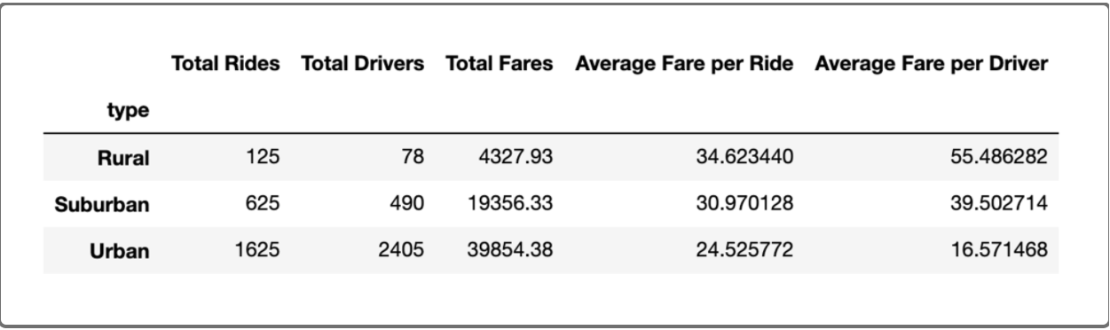

Based on the type of city the passenger is boarding in, we may infer from our data what kind of fares would be demanded. Even though we didn't study every single city, we still have a good understanding of how weekly fees will change depending on the type of city, which is enough knowledge to determine the rates that will need to be charged once we can identify the sort of city the consumer lives in. In conclusion, we can conclude with confidence that rural areas will command a higher fare because fewer workers would move there, the travel distance is probably greater, and the average fare per ride and driver is the highest.